Leaflet Mapping API Interface

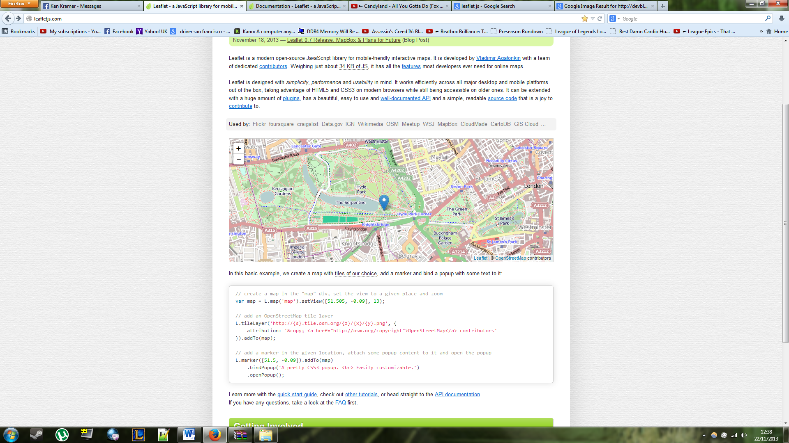A point of interest (POI) on the map will be represented by a pin on the map similar to the one below.

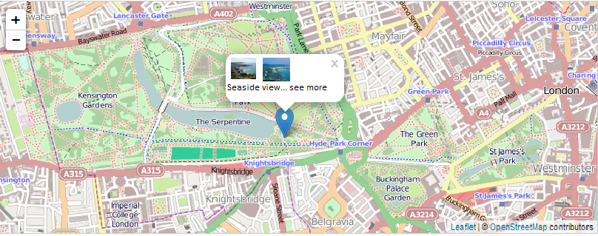When the user clicks on the pin a pop up will appear with thumbnails of the images taken at the POI and a short description of the location. Clicking on an image will allow the user to view a larger version of the image, and clicking on “see more” will show them more details about the POI (map coordinates, time stamp).

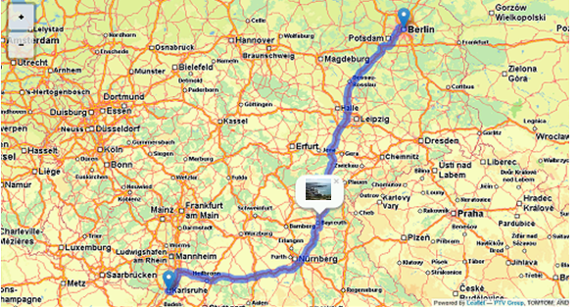The route will be shown on the map as a line with pins along the line for the POI’s as shown below.